NATIONAL OPEN UNIVERSITY OF NIGERIA
JOS STUDY CENTER

ARTICLE TO SPEECH CONVERTER FOR THE VISUALLY IMPAIRED
BY
KENNETH UCHECHUKWU AWOM
NOU201080511

B.SC COMPUTER SCIENCE
400 LEVEL

A PROJECT SUBMITTED IN PARTIAL FULFILLMENT OF THE REQUIREMENTS FOR THE AWARD OF BACHELOR OF SCIENCE (B.Sc.) AT THE DEPARTMENT OF COMPUTER SCIENCE, FACULTY OF SCIENCES
NATIONAL OPEN UNIVERISITY OF NIGERIA

JOS, PLATEAU STATE.
DECEMBER, 2023

DECLARATION
I AWOM KENNETH UCHECHUKWU, declare this project titled "Article to Speech Converter App for the Visually Impaired”, is the product of my research efforts, undertaken under the supervision of Dr. Godwin Thomas. It has not been presented and will not be presented elsewhere for the award of a degree or certificate. All sources have been fully acknowledged.

_________________________________ ______________________
AWOM KENNETH UCHECHUKWU Date NOU201080511

CERTIFICATION
This is to certify that this project titled “Article to Speech Converter App for the Visually Impaired” conducted by Awom Kenneth Uchechukwu has been carefully read and approved, having satisfied the requirement for Bachelor of Science in Computer Science, in the Department of Computer Science, Faculty of Science, National Open University Of Nigeria.

_________________________ ______________________
Dr. Godwin Thomas Date Project Supervisor
_________________________ ________________________
Dr. Philip S.Taching Date
Centre Director
________________________ _________________________ Prof. Monioluwa Olaniyi Date
Dean Faculty Of Science
___________________________ __________________________ External supervisor Date

DEDICATION
I dedicate this project work to everyone still struggling to find themselves.

ACKNOWLEDGEMENT
My profound acknowledgement goes to God Almighty for the gift of life good health, and protection and for seeing me through the beginning to the end of my experience in developing this project.
My regards go to my parents, Mr Bernard and Mrs Christiana Awom, who are my role models and backbones guiding me through this thing called life and my educational pursuit, I say may the good God bless you both.
My sincere appreciation goes to my project supervisor Dr. Godwin Thomas, who assisted me in every possible way, thank you sir for your support, kind words and motivation.
God bless you all, Amen.

TABLE OF CONTENTS

DECLARATION 2
CERTIFICATION 3
DEDICATION 4
ACKNOWLEDGEMENT 5
TABLE OF CONTENTS 6
LIST OF FIGURES 9
ABSTRACT 11
CHAPTER ONE 12
1.0. INTRODUCTION 12
1.2. BACKGROUND OF STUDY 12
1.2. PROBLEM AREA 13
1.3. PROBLEM STATEMENT 14
1.4. SIGNIFICANCE OF THE STUDY 15
1.5. RESEARCH QUESTIONS 16
1.6 AIM AND OBJECTIVES OF THE STUDY 18
1.7. RESEARCH METHODOLOGY 18
1.8. SCOPE AND LIMITATION OF THE STUDY 19
1.8.1. Scope of the study: 19
1.8.2. Limitation of the study: 19
1.9. PROJECT ORGANIZATION 20
1.9.1.Chapter One: 20
1.9.2.Chapter Two: 20
1.9.3. Chapter Three: 20
1.9.4.Chapter Four: 20
1.9.5. Chapter five: 21
1.10. DEFINITION OF TERMS 21
1.10 CONCLUSION 22
CHAPTER TWO 23
2.0. INTRODUCTION 23
2.1. ACCESSIBILITY TECHNOLOGIES 23
2.1.1. Text-to-Speech Synthesis 23
2.1.2. Natural Language Processing (NLP) 24
2.2. PREVIOUS SOLUTIONS 24
2.2.1. Existing Article to Speech Converters: 25
2.2.2. Strengths and Weaknesses: 25
2.3. REVIEW OF RELATED WORKS 25
2.3.1. Text-to-Speech Conversion Technologies 25
2.3.2. Challenges and Opportunities in Text-to-Speech Conversion 26
2.3.3. Previous Solutions for Article to Speech Conversion 26
2.3.4. User Interface Design in Article to Speech Converters 27
2.3.5. Integration of Natural Language Processing 28
2.4. DESIGN METHODOLOGY 28
2.4.1. Structured System Analysis And Design Methodology (SSADM) 29
2.4.2. Prototyping 29
2.5. CONCLUSION 30
CHAPTER THREE 32
3.0. INTRODUCTION 32
3.1. SYSTEM ARCHITECTURE 32
3.1.1. Overall System Design 32
3.1.2. Text-to-Speech Synthesis 33
3.1.3. Natural Language Processing 33
3.1.4. User Interface Design 34
3.1.5. Conceptual Model 35
3.2. IMPLEMENTATION DETAILS 36
3.2.1. Technical Aspects of Text-to-Speech Synthesis 36
3.2.2. Integration of Natural Language Processing 37
3.2.3. User Interface Development 38
3.2.4. User Case Model 38
3.2.5. TTS Voice Synthesizer Sequence 39
3.2.6. A Typical TTS System 40
3.3. HOW COMPONENTS ARE USED IN A FLASK APPLICATION 41
3.3.1. “Flask” 41
3.3.2. “Render_template” 41
3.3.3. “request” 42
3.4. SYSTEM FLOWCHART 42
3.5. ARCHITECTURAL DESIGN 45
3.5.1. Web App Architecture 45
3.5.2. Explanation 46
3.6. CONCLUSION 47
CHAPTER FOUR 48
4.0. INTRODUCTION 48
4.1. SYSTEM REQUIREMENTS 48
4.2. IMPLEMENTATION METHOD 49
4.2.1. Install Flask and other required libraries 50
4.2.2. Create a file named app.py with the following content 51
4.2.3. Create a folder named templates and inside it, create a file named index.html 53
4.2.4. Run the Flask app 54
4.3. CHOICE OF PROGRAMMING LANGUAGE 54
4.4. OPERATING THE PROTOTYPE 56
4.4.1. Wire Frame 58
4.4.2. Front End Layout 59
4.5. EVALUATION METRICS 59
4.5.1. Usability Testing 60
4.5.2. Performance Metrics 60
4.5.3. News Article Link Testing and Academic PDF Link Testing 60
4.6. USER FEEDBACK 61
4.6.1. Customization Preferences 61
4.6.2. Accuracy and Naturalness 61
4.6.3. Integration with Digital Content 62
4.6.4. Iterative Improvements 62
4.7. DISCUSSION 62
4.8. CONCLUSION 63
CHAPTER FIVE 64
5.0 INTRODUCTION 64
5.1 SUMMARY OF FINDINGS 64
5.2. ACCOMPLISHMENT OF OBJECTIVES 65
5.2.1. FIRST SUB-OBJECTIVE 66
5.2.2. SECOND SUB-OBJECTIVE 66
5.2.3 THIRD SUB-OBJECTIVE 67
5.2.4 FOURTH SUB-OBJECTIVE 67
5.3. SUGGESTION FOR FURTHER RESEARCH 67
5.3.1. Integration with Emerging Technologies 68
5.3.2. Enhanced Digital Content Integration 68
5.3.3. Collaboration with Accessibility Organizations 68
5.3.4. Cross-Platform Compatibility 69
5.3.5. Incorporation of Voice Commands 69
5.3.6. Long-Term User Studies 69
5.4. KEY ACHIEVEMENTS 69
5.5 CONCLUSION 70
REFERENCES 71
APPENDIX 76

LIST OF FIGURES
Figure 3.0 The Conceptual model for the Article to Speech Converter App for the Visually Impaired………………………………………………………………………………………..35
Figure 3.1 Block diagram of Text-to-Speech Synthesis..………………………………………36
Figure 3.2 Text processing components………………………………………………………..37
Figure 3.3 The user case model of the user of the Article to Speech Converter App…………38
Figure 3.4 Sequence diagram for the TTS voice synthesizer…………………………………..39
Figure 3.5 Overview of a typical TTS system (Wikipedia)..........................................................40
Figure 3.6 An Instance of the Flask class………………………………………………………..41
Figure 3.7 Render Template Diagram……………………………………………………………41
Figure 3.8 Request Diagram……………………………………………………………………..42
Figure 3.9 System Flowchart Diagram…………………………………………………………..43
Figure 3.10 Architectural Design Diagram…..…………………………………………………..45
Figure 4.1 Installing the Flask Packages………………………………………………………..50
Figure 4.2 Main Python Code…………………………………………………………………..51
Figure 4.3 Saving the audio path……………………………………………………………….52
Figure 4.4 Index.html code……………………………………………………………………..53
Figure 4.5 Running the App in the local sever…………………………………………………54
Figure 4.6 The wire frame………………………………………………………………………58
Figure 4.7 The Front end layout of the Article to Speech Converter App for the Visually Impaired…………………………………………………………………………………………59

ABSTRACT
This undergraduate research paper presents the design, development, and evaluation of an Article to Speech Converter App tailored for individuals with visual impairments. The project aims to address the accessibility challenges faced by the visually impaired community when accessing textual content, providing a technological solution that enhances their ability to consume information independently. The implementation leverages Python programming, incorporating text-to-speech synthesis, natural language processing, and a user-centric design approach.

CHAPTER ONE

1.0. INTRODUCTION
This chapter contains the background of the study, problem area, statement of problem, significance of the study, research question, aim and objectives, research methodology, scope and limitations of the study, project organisation and definition of terms. In this chapter we will be going over the aims of the research to address challenges developing an Article to Speech Converter App for the Visually Impaired using the Python programming language. While setting up the structure for the rest of the research.

1.2. BACKGROUND OF STUDY
The visually impaired community faces significant challenges in accessing textual information present in articles and documents, hindering their ability to independently consume information and engage with written content (OpenAI, 2023). While various assistive technologies exist to address this issue, there is a need for a more tailored and user-friendly solution that leverages the capabilities of modern programming languages.This research aims to fill this gap by developing an application using the Python programming language, known for its versatility, ease of use, and extensive library support.
The ubiquity of Python in the field of artificial intelligence, natural language processing, and user interface development makes it an ideal choice for creating a sophisticated yet simple application (Ubale et al., 2022). Leveraging Python's extensive ecosystem of libraries, the app aims to offer a seamless and efficient conversion of written articles into spoken words, allowing visually impaired individuals to access information effortlessly.
Moreover, the current landscape of assistive technologies predominantly relies on applications that may not fully cater to the nuanced requirements of visually impaired users. Such users often encounter difficulties in navigating through articles, discerning complex structures, and customizing the reading experience according to their preferences. The proposed Article to Speech Converter seeks to address these challenges by providing a tailored solution that prioritizes user-centric design, accessibility, and ease of integration with digital content sources (Kreuzen, Dull, De Rover, & Span, 2022).
Basic research in speech science over the last half century has benefited greatly from our endeavors to synthesize speech by machine. For example, developing programs for simulating the time course of fundamental frequency variation over sentences and longer utterances has been an indispensable research tool in our basic understanding of intonation. In England (details differ in the other nations of the UK), STT is available to students in Colleges of Further Education (these cater mainly for 16–19-year-olds not aiming for the more academic Advanced Level examinations), and since 2015 students have been able to use the technology in General Certificate of Secondary Education (GCSE) examinations (mainly taken by 16-year- olds). GCSE examinations are overseen by The Joint Council for Qualifications (JCQ). Rules and regulations for the use of assistive technology (AT) and word processors have changed over the years, and access to these technologies has widened; also, a deduction of marks from students using STT in these examinations, and thus unable to demonstrate their own command of spelling and punctuation, has gradually been reduced from 20% to 5% (Kambour., Simon, & Brooks, 2023).
This project, the aim is to study how blog posts and news articles can be converted in a Text-To-Speech conversion that can be used as a communication or education aid. With limitations to literature and research in this area, the project will expand its usefulness to the areas of academic literature and the possibility of converting academic texts to audio.

1.2. PROBLEM AREA
Visually impaired individuals encounter substantial barriers when it comes to accessing written content, including articles and documents (Tushar, 2022). The lack of tailored, user-friendly solutions that address the specific needs of this community results in a digital divide, impeding their ability to independently engage with textual information. Existing text-to-speech systems often fall short of providing a customizable, efficient, and inclusive experience, highlighting the need for a specialized solution.
Moreover, the limitations of current technologies become even more evident when considering the diverse formats and structures of articles, making it challenging for visually impaired users to navigate and comprehend complex written content. The absence of an accessible and adaptable Article to Speech Converter App further exacerbates the information disparity faced by this community, hindering their educational and informational autonomy (Yasuda, Wang, & Yamagishi, 2021).
The existing landscape of assistive technologies lacks a dedicated and comprehensive Article to Speech Converter App designed specifically for the visually impaired. This gap results in a critical challenge for individuals with visual impairments who seek to access written content independently. Current text-to-speech systems often lack the flexibility to accommodate the diverse needs of users and fail to address the intricacies of various article formats, leading to a suboptimal user experience (Li, Ma, & Yin, 2021).
Furthermore, the absence of a user-friendly, Python-based solution adds to the complexity of the problem (Sneha et al, 2022). While Python is widely recognized for its versatility and extensive library support, its potential for contributing to the development of an inclusive and efficient Article to Speech Converter App has not been fully explored.

1.3. PROBLEM STATEMENT
This research aims to address these challenges by developing an Article to Speech Converter App for the Visually Impaired using the Python programming language. By doing so, it seeks to bridge the existing gap in assistive technologies, providing visually impaired individuals with a powerful and customizable tool to access written content seamlessly. Through the development of this application, the study endeavours to contribute to the empowerment and inclusion of visually impaired individuals in the digital realm.

1.4. SIGNIFICANCE OF THE STUDY
The development of an Article to Speech Converter App for the Visually Impaired using Python holds significant implications for enhancing accessibility and inclusivity in the digital realm (Kambouri, Simon, & Brooks, 2023). This research contributes to the existing body of knowledge by addressing the following key areas:
Empowering Visually Impaired Individuals:
The study aims to empower visually impaired individuals by providing them with a specialized tool that enhances their ability to independently access and consume written content (Eren, & Demiroglu, 2023). Through a user-centric design and the utilization of Python's capabilities, the application seeks to promote autonomy in information retrieval.
Closing the Accessibility Gap:
The research endeavours to bridge the existing gap in assistive technologies by creating a tailored solution that meets the unique needs of visually impaired users (Kreuzen, Dull, De Rover, & Span, 2023). By focusing on accessibility compliance and user customization, the application aims to provide an inclusive digital experience.
Contributing to Assistive Technology Advancements:
The development of a Python-based Article to Speech Converter App contributes to the advancement of assistive technologies, particularly in the realm of natural language processing and user interface design. This research aims to showcase the potential of Python as a tool for creating sophisticated and accessible applications.
Enhancing Educational Opportunities:
By enabling visually impaired individuals to access educational materials more effectively, the study seeks to enhance educational opportunities (Mutawa, 2023). The application's integration with digital content sources and its adaptability to various article formats can positively impact the educational experiences of users.
Promoting Inclusivity in the Digital Space:
The development of a specialized app aligns with the broader goal of creating a more inclusive digital space. It recognizes the diverse needs of users with visual impairments and strives to provide them with a seamless and adaptable tool for engaging with online content (Islam, Ahmad, & Rahman, 2024).

1.5. RESEARCH QUESTIONS
To guide this study and achieve its objectives, the following research questions will be addressed:
Question: What are the specific challenges faced by visually impaired individuals in accessing and comprehending written articles using existing assistive technologies?
This question aims to identify the shortcomings of current solutions and the specific needs of the target user group.

Question: How can the Python programming language be leveraged to develop a user-friendly and efficient Article to Speech Converter App for the Visually Impaired?
This question focuses on exploring the capabilities of Python, its libraries, and frameworks in addressing the identified challenges and meeting the requirements of the user-centric design.

Question: What impact does the developed application have on the accessibility and usability of written content for visually impaired individuals?
This question assesses the effectiveness of the developed app in enhancing the accessibility and usability of articles and documents, considering user feedback and testing outcomes.

Question: How can the application be integrated with digital content sources to provide a comprehensive solution for visually impaired users?
This question explores the feasibility and strategies for integrating the app with online sources, digital libraries, and news websites to expand its functionality and relevance.
These research questions guide the investigation, development, and evaluation of the Article to Speech Converter App for the Visually Impaired using Python. Through addressing these questions, the study aims to contribute valuable insights to the fields of assistive technology and accessibility.

1.6 AIM AND OBJECTIVES OF THE STUDY
Aim:
- To develop an Article to Speech Converter App specifically designed for visually impaired individuals.

Objectives:
- Conduct a needs assessment to identify the specific challenges and preferences of visually impaired users in accessing textual content.
- Identify the requirements through interviews and utilize Python libraries and frameworks for text-to-speech synthesis, natural language processing, and user interface design.
- Develop an intuitive and customizable user interface that prioritizes accessibility and usability for visually impaired individuals.
- Ensure the application complies with accessibility standards, such as WCAG (Web Content Accessibility Guidelines), to cater to users with varying levels of visual impairment.

1.7. RESEARCH METHODOLOGY
The study will adopt qualitative research methods including Literature review and interview, Technology Exploration; Review and analysis of Python libraries and frameworks relevant to text-to-speech synthesis, natural language processing, and user interface design. As a proof of concept a prototype was created.Application Development and the utilization of Python for application development, with a focus on user-centric design principles. Implementation of accessibility standards, such as WCAG (Web Content Accessibility Guidelines), to ensure the application meets the needs of users with visual impairments. Conducting usability testing and gathering feedback through interviews and surveys with visually impaired users. Exploration of methods to integrate the application with online sources, digital libraries, and news websites.

1.8. SCOPE AND LIMITATION OF THE STUDY

1.8.1. Scope of the study:
- The study focuses on developing an Article to Speech Converter App for visually impaired users.
- Python will be the primary programming language used for application development.
- The research will explore customization features, accessibility compliance, and integration with digital content sources.

1.8.2. Limitation of the study:
- The study may face limitations in achieving universal customisation due to the diverse preferences of visually impaired users.
- Accessibility standards compliance may not fully address all variations in the needs of users with different levels of visual impairment.
- Integration with digital content sources may be constrained by the availability of APIs and cooperation from external platforms.

1.9. PROJECT ORGANIZATION
This research project covers almost all you need to know about drug procurement and distribution tracking systems.

1.9.1.Chapter One:
Chapter one is the introduction and it covers the statement of the problem, objectives of the study, significance of the study, scope and limitation of the study, and definition of terms.

1.9.2.Chapter Two:
Chapter two, is the literature review; it gives the detailed meaning of every associated word in my topic and reviews work related to the proposed project.

1.9.3. Chapter Three:
Chapter Three, design and analysis; looks at proposed design and operations for the system and the methods used.

1.9.4.Chapter Four:
Chapter four, System Design and Implementation; looks at the implementation and operation of the proposed system.

1.9.5. Chapter five:
Chapter five looks at summary, recommendation and conclusion.

1.10. DEFINITION OF TERMS
TTS: Text-to-Speech
WCAG: Web Content Accessibility Guidelines
NLP: Natural Language Processing
TPS: Transaction Processing System
OOADM: Object-oriented analysis and design mythology
SWEM: Software Engineering Methodology
SSADM: Structured System Analysis And Design Methodology
nltk: Natural Language Toolkit
gTTS: Google Text-to-Speech
UML: Unified Modelling Language

1.10 CONCLUSION
This chapter started by introducing the research work and discussing the background of the study. The problem statement was identified and the project's primary aim was set. Objectives for the research work were defined alongside the methodology for achieving these objectives. The scope and limitations of the project were also highlighted.
The next chapter will focus on the literature review of existing technologies and solutions in the field of text-to-speech conversion, and accessibility,

CHAPTER TWO
LITERATURE REVIEW

2.0. INTRODUCTION
This chapter reviews existing literature, technologies and solutions in the field of text-to-speech conversion, accessibility, and user interface design for visually impaired individuals.
This chapter establishes the foundational knowledge required for developing an Article to Speech Converter App for the Visually Impaired using the Python programming language. By drawing on insights from accessibility technologies and analyzing previous solutions, we can create a robust and user-friendly application that addresses the unique challenges faced by individuals with visual impairments.

2.1. ACCESSIBILITY TECHNOLOGIES
Accessibility technologies play a pivotal role in empowering individuals with visual impairments by providing them with tools to access and interact with digital content (Dutoit, 1993). Text-to-speech synthesis and natural language processing are key components in creating applications that cater to the unique needs of visually impaired users.

2.1.1. Text-to-Speech Synthesis
Text-to-speech (TTS) synthesis is a technology that converts written text into spoken words. Various TTS engines and libraries are available, each with its strengths and limitations. Understanding the nuances of different TTS techniques is crucial for selecting an appropriate solution for our Article to Speech Converter App (Lemmetty, 1999). Previous research in TTS has explored methods such as concatenative synthesis, formant synthesis, and parametric synthesis, each offering distinct advantages in terms of naturalness and efficiency.

2.1.2. Natural Language Processing (NLP)
Natural language processing is another critical aspect of our project, as it involves the interaction between the user and the app (Dutoit, 1993). NLP algorithms facilitate the app's ability to interpret and understand the input text, ensuring accurate and contextually relevant speech output. Previous studies in NLP have addressed challenges such as language modelling, part-of-speech tagging, and sentiment analysis, providing insights that can inform the development of our application.

2.2. PREVIOUS SOLUTIONS
Several applications and solutions have been developed to assist visually impaired individuals in accessing written content. Notable examples include screen readers, Braille displays, and dedicated text-to-speech applications (Suendermann, 2010 ). While these solutions have made significant strides in improving accessibility, there is a need for a specialized Article to Speech Converter App that focuses on transforming written articles into spoken words.

2.2.1. Existing Article to Speech Converters:
Reviewing previous solutions in this domain is crucial for identifying successful features and understanding areas that require improvement. Applications like NaturalReader, Voice Dream Reader, and Kurzweil 3000 have provided valuable insights into user interface design, customizable features, and integration with digital content sources. Analyzing these solutions will guide the design and implementation of our Python-based app.

2.2.2. Strengths and Weaknesses:
A critical analysis of existing solutions reveals their strengths and weaknesses. While some applications excel in voice quality and speed, others may lack customization options or struggle with complex sentence structures. Understanding these nuances will help us refine our project objectives and prioritize features that address the specific needs of our target users.

2.3. REVIEW OF RELATED WORKS

2.3.1. Text-to-Speech Conversion Technologies
The development of Article to Speech Converter applications for the visually impaired is situated within the broader context of Text-to-Speech (TTS) conversion technologies. Ubale et al. (2022) provided a comprehensive review of TTS converters, emphasizing the significance of these technologies in transforming written text into audible content. The study explores various TTS techniques, including concatenative synthesis, formant synthesis, and parametric synthesis, shedding light on their respective advantages and limitations. Understanding the nuances of TTS technologies is crucial for selecting an appropriate solution for our application.
The study conducted by Mache, Suhas, Baheti, Manasi, Mahender, C., and Professor, Asst. (2015) provides a comprehensive review of Text-To-Speech (TTS) synthesizers, offering valuable insights into the evolution, features, and challenges of this technology. The research, published in the "International Journal of Advanced Research in Computer and Communication Engineering," aims to enhance our understanding of TTS synthesizers and their applications.

2.3.2. Challenges and Opportunities in Text-to-Speech Conversion
Sneha et al. (2022) offer a valuable review that delves into the challenges and opportunities in the realm of Text-to-Speech conversion. The paper highlights the importance of addressing complexities related to language modelling, pronunciation accuracy, and intonation to enhance the naturalness of the generated speech. Insights from this review contribute to the understanding of the specific challenges that need to be addressed in the development of our Article to Speech Converter for the visually impaired.

2.3.3. Previous Solutions for Article to Speech Conversion
Existing solutions play a pivotal role in shaping the landscape of Article to Speech Converters. Ubale et al. (2022) provide insights into the features and capabilities of various converters, emphasizing the need for user-friendly interfaces and customizable options. Additionally, Sneha et al. (2022) offer a critical analysis of previous solutions, identifying strengths and weaknesses. This knowledge is invaluable in guiding the design and implementation of our Python-based Article to Speech Converter for optimal user experience.
Pande and Kumar's (2014) research article, titled "A Smart Device for People with Disabilities using ARM7," published in the International Journal of Engineering Research & Technology (IJERT), explores the development and application of smart devices designed specifically to cater to the needs of individuals with disabilities. The study presents a valuable contribution to the field of assistive technology, focusing on the utilization of the ARM7 architecture for creating innovative solutions. This provides a general overview of assistive technologies designed to enhance the quality of life for people with disabilities. It discusses the significance of technological advancements in fostering independence and improving accessibility for individuals facing physical or cognitive challenges.

2.3.4. User Interface Design in Article to Speech Converters
User interface design is crucial to creating an accessible and user-friendly Article to Speech Converter. Ubale et al. (2022) discuss the significance of intuitive interfaces, considering the diverse needs of users, including those with visual impairments. This insight is instrumental in shaping the graphical user interface of our application, ensuring that it aligns with best practices in accessibility and usability.

2.3.5. Integration of Natural Language Processing
Natural Language Processing (NLP) is a key component in enhancing the efficacy of Article to Speech Converters. Sneha et al. (2022) touch upon the importance of NLP algorithms in interpreting user input, processing textual content, and ensuring contextually relevant speech output. This understanding guides the integration of NLP into our application, addressing challenges related to language complexity and diverse article structures.

2.4. DESIGN METHODOLOGY
Software Engineering Methodology (SWEM) is the body of methods, rules, postulates, procedures, and processes used to manage a software engineering project (Ekwonwune, 2018). He classified software engineering into the following categories:
I. The pragmatic system analysis and design methodology (SSADM)
II. Object-oriented analysis and design mythology (OOADM)
III. Prototype Methodology
IV. Expert System.

2.4.1. Structured System Analysis And Design Methodology (SSADM)
This project work is developed with this methodology (SSADM). The pragmatic system analysis and design methodology consist of an investigation of the present system, a definition of the new system, establishment of constraints and system analysis documentation which should provide the following:
1. Cost/ Benefit/Schedule report for each suitable system
2. Database requirement
3. Physical requirement of hardware and personnel
4. Conversion requirement
This methodology (SSADM) involves developments such as system flow chart, Job steps, and Program narratives which enhance organisation for computer execution:
1. Prototype Methodology
2. Object Oriented Analysis and Design Methodology
3. Pragmatic System Analysis and Design Methodology.

2.4.2. Prototyping
A prototyping methodology is a methodology in a software development process which allows developers to greater portions of the solution to demonstrate functionality and make needed refinements before developing the final solution. It is somewhat similar; it produces a “throw-away” solution that is designed for the sole purpose of verifying user functionality and demonstration capability.
Prototyping is an excellent way for the development team to confirm an understanding of the requirements and ensure that the proposed solution is consistent with business expectations. This type of methodology is normally used or works very well with online transaction processing system (TPS) WEB-based Development and is also very useful for confirming business intelligence analytic requirements. Some of its service steps are
I. Problem recognition/identification
II. Feasibility study
III. Analysis
IV. Implementation
V. Testing
VI. Maintenance
The implementation stage of the system development process involves program coding. Testing and debugging, conversion, trading and handover. While maintenance deals with ensuring the system is operational after the changeover from the old system to the new system Ekwonwune (2018).

2.5. CONCLUSION
This chapter started by introducing the roles accessibility technologies play in empowering individuals with visual impairments. Highlighting Text-to-Speech Synthesis and Natural Language Processing (NLP). The chapter also reviews the literature on previous solutions and tries to explain their weaknesses and strengths.

CHAPTER THREE
SYSTEM ANALYSIS AND DESIGN

3.0. INTRODUCTION
In the previous chapter, the literature associated with Text-to-speech synthesis and Natural Language Processing were identified, which formed the foundational knowledge needed to understand this research. This chapter focuses on the system architecture and design of the proposed system.

3.1. SYSTEM ARCHITECTURE
The design and development of the Article to Speech Converter App for the Visually Impaired involves a carefully planned system architecture that integrates various components to achieve a seamless and effective user experience.

3.1.1. Overall System Design
The architecture of the system encompasses the core functionalities of text-to-speech synthesis, natural language processing, and user interface design. The Python programming language is chosen as the primary tool for its versatility, ease of integration, and rich ecosystem of libraries.

3.1.2. Text-to-Speech Synthesis
Implementation of the text-to-speech synthesis involves selecting a suitable TTS engine or library compatible with Python. The chosen solution should balance naturalness, speed, and customization options. The synthesis process will be optimized to ensure efficient conversion of written articles into high-quality spoken content.
Decided to use the nltk library. nltk stands for Natural Language Toolkit. It is a library in Python that provides tools for working with human language data. In this code, it's likely being used for tokenization (nltk.download('punkt') and article.nlp()). Tokenization is the process of breaking text into individual words or phrases, which is often a necessary step in natural language processing tasks.

3.1.3. Natural Language Processing
The natural language processing component focuses on interpreting user input, processing textual content, and ensuring accurate speech output. Python libraries such as NLTK (Natural Language Toolkit) and spaCy will be explored for their capabilities in handling language-related tasks. The NLP algorithms will be fine-tuned to accommodate the nuances of diverse articles and provide a contextually relevant auditory experience.
Here the gTTS (Google Text-to-Speech) module is used for converting text into speech. It provides a simple interface for creating audio files from text.

3.1.4. User Interface Design
The user interface design is a critical aspect of ensuring accessibility and user-friendliness. A graphical user interface (GUI) will be developed using a Python framework called Flask, allowing users to interact with the app effortlessly. The GUI will feature customization options, ensuring that users can tailor the app to their preferences.
Flask is a web framework for Python that simplifies the process of building web applications. It provides tools, libraries, and patterns to help developers build web applications quickly and efficiently.

3.1.5. Conceptual Model
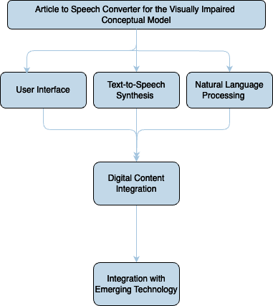
Figure 3.0 The Conceptual model for the Article to Speech Converter App.
As shown in figure 3.0 the model explains shows the process in which the User Interface handle the input interface, customization, fonts and color schemes etc. The Test-to-Speech Synthesis will enable engine integration and gTTS and pyttsx3 etc. The Digital content integration will process onlines sources of information and integrate with web content through audio. Giving rise to future integration with emerging technology.

3.2. IMPLEMENTATION DETAILS

3.2.1. Technical Aspects of Text-to-Speech Synthesis
The text-to-speech synthesis will be implemented using a Python library, such as gTTS (Google Text-to-Speech) or pyttsx3, to generate spoken content. Parameters such as voice pitch, speed, and volume will be customisable to accommodate user preferences. Special attention will be given to handling punctuation, pauses, and emphasis to enhance the naturalness of the spoken output.
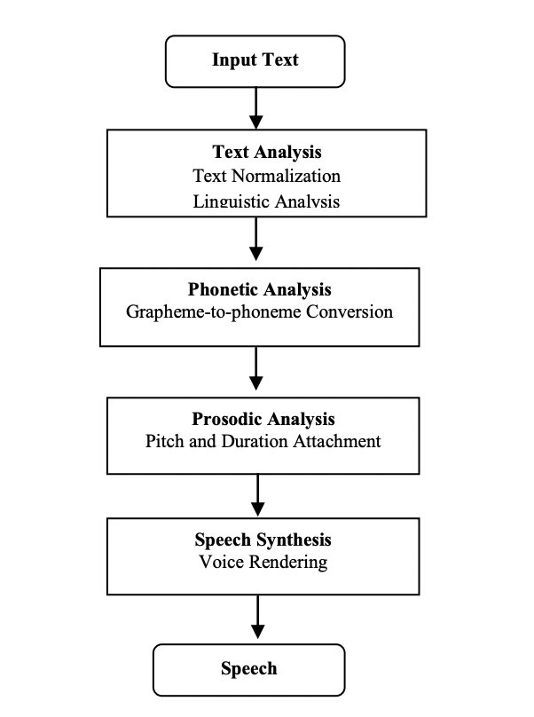
Figure 3.1 Block diagram of Text-to-Speech Synthesis.
As shown in figure 3.1 we can see a block diagram of Text to Speech system. For natural sounding speech synthesis, it is essential that the text processing component produce an appropriate sequence of phonemic units corresponding to an arbitrary input text.

3.2.2. Integration of Natural Language Processing
The NLP component will involve the use of Python NLP libraries to preprocess and analyze textual content. Techniques such as tokenization, part-of-speech tagging, and sentence structure analysis will be employed to enhance the accuracy and coherence of the speech output. Continuous refinement of NLP algorithms will be carried out based on user feedback.
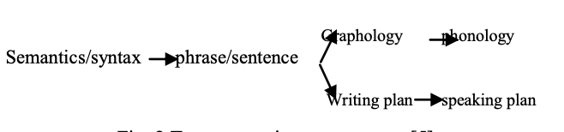
Figure 3.2 Text processing components.
Figure 3.2 shows the text processing components that deals with low level processing issues such as sentence segmentation and word segmentation.

3.2.3. User Interface Development
The graphical user interface will be designed to prioritize accessibility and ease of use. Users will have the ability to input articles through various formats, including copy-pasting text or importing documents. Customization options will include font size, colour schemes, and speech preferences. The interface will be tested with visually impaired individuals to ensure its effectiveness and intuitiveness.

3.2.4. User Case Model
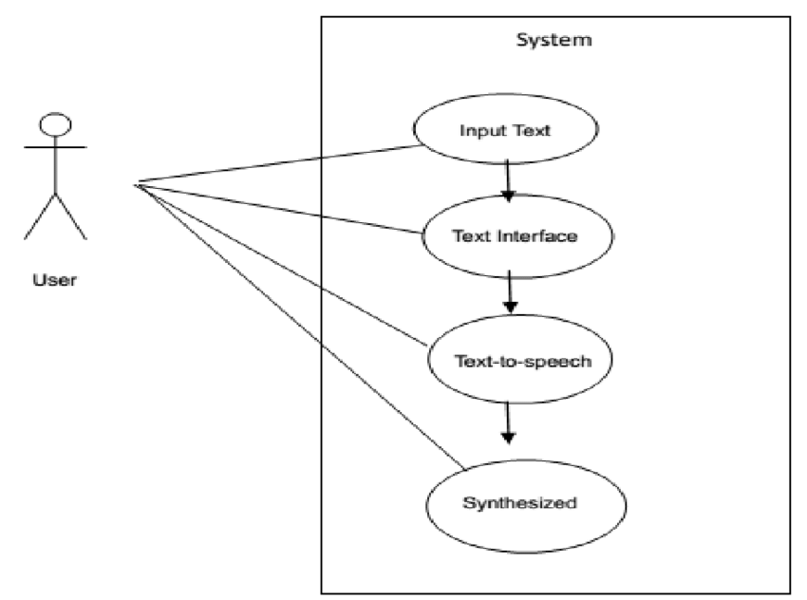
Figure 3.3 The user case model of the user of the Article to Speech Converter App
As shown in figure 3.3 the user case model diagram is a representation of a user’s interaction with the system that shows the relationship between the user and the different use cases in which the user is involved.

3.2.5. TTS Voice Synthesizer Sequence
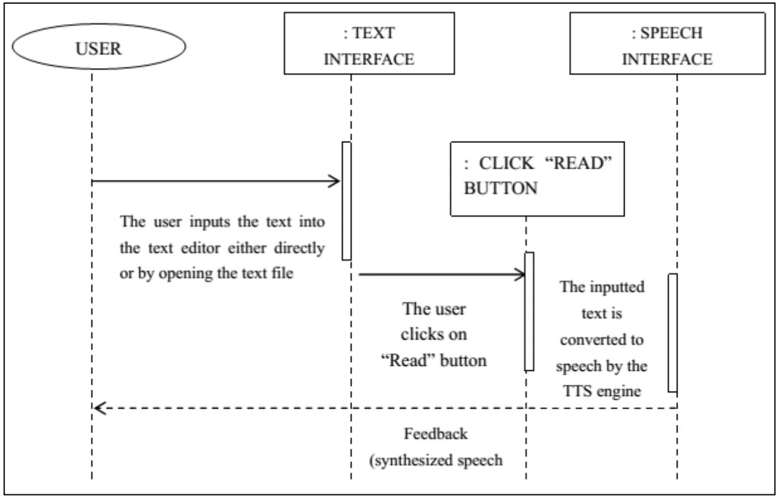
Figure 3.4 Sequence diagram for the TTS voice synthesizer
As shown in figure 3.4 the Sequence diagrams above, a subset of behavioral diagrams, emphasize the flow of control and data among the things in the system being modeled. An example is sequence diagram. Sequence diagram is an example interaction diagram that shows how objects communicate with each other in terms of a sequence of messages. Also indicates the lifespan of objects relative to those messages. It graphically depicts how objects interact with each other via messages in the execution of a use case or operation. They illustrate how messages are sent and received between objects and in what sequence.

3.2.6. A Typical TTS System
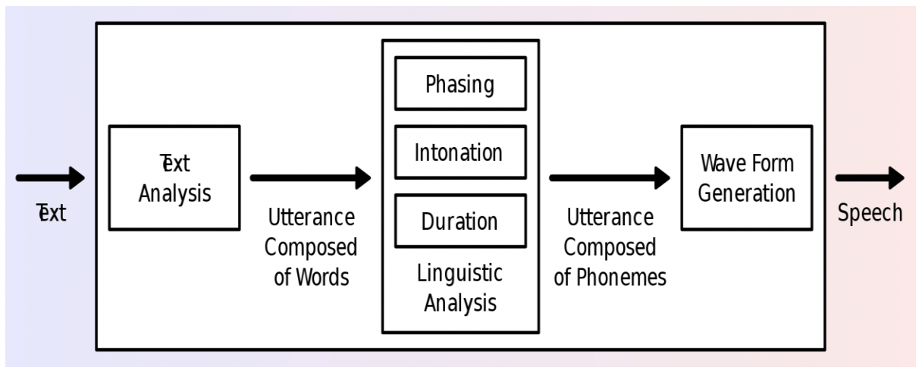
Figure 3.5 Overview of a typical TTS system (Wikipedia)
Figure 3.5 show the processes in which the text goes from text to speech in a typical TTS system. Highlighting the text analysis; looking at phasingm, intonation, duration and even composition of phonemes.

3.3. HOW COMPONENTS ARE USED IN A FLASK APPLICATION

3.3.1. “Flask”
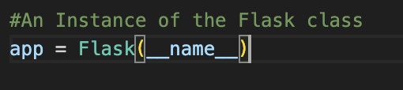
Figure 3.6 An Instance of the Flask class
Figure 3.6 shows the instance of the flask class. You create an instance of the Flask class to define your web application. It is the core of your application and is responsible for handling requests and routing them to the appropriate view functions.

3.3.2. “Render_template”
This function is used inside your view functions to render HTML templates. It takes the name of the template file as an argument and can also accept additional data that you want to pass to the template.
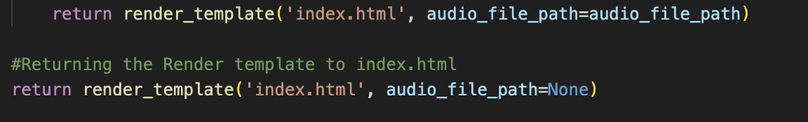
Figure 3.7 Render Template Diagram
As shown in figure 3.7, the code snippet is used to render the HTML template named 'index.html' and pass the audio_file_path variable to the template.

3.3.3. “request”
This object is used to access data from incoming HTTP requests. In a web application with forms, you can use request.form to access form data.
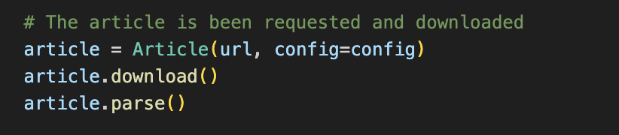
Figure 3.8 Request Diagram
As shown in figure 3.8, the code snippet is used to get the value entered in the form field with the name 'article_url'.
These components together help you create a web application where users can input a URL, submit a form, and receive a response based on the input. The Flask framework facilitates the handling of HTTP requests and responses, while render_template allows you to generate HTML dynamically, and request helps you retrieve data submitted by users.

3.4. SYSTEM FLOWCHART
This is a simplified flowchart that outlines the major steps in the web app.
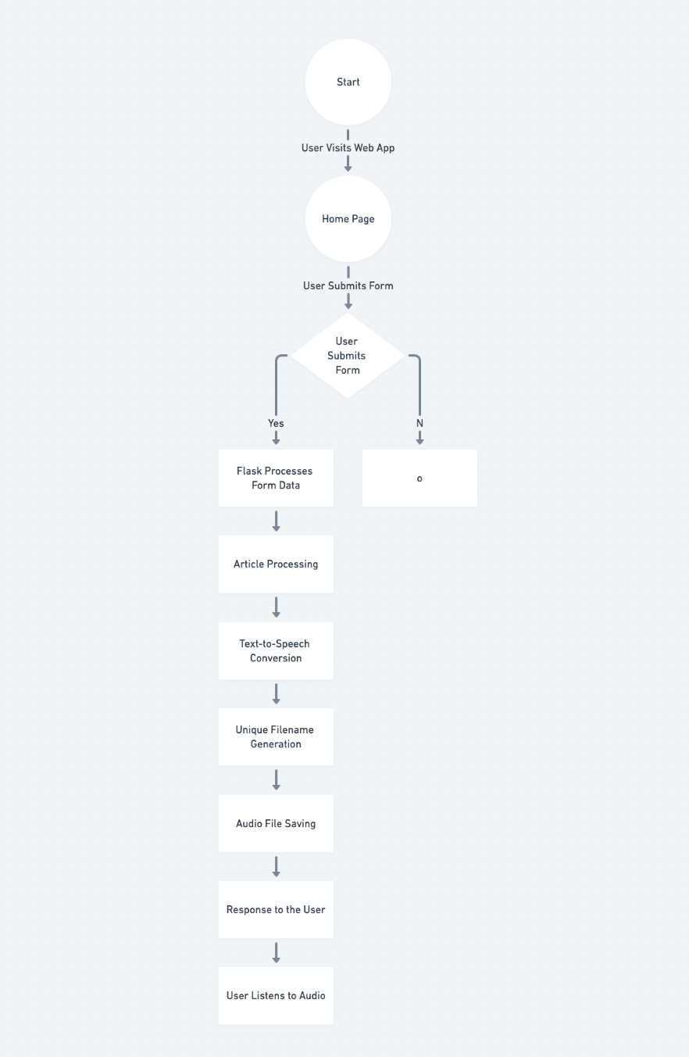
Figure 3.9 System Flowchart Diagram
As explained in figure 3.9. The diagram shows the hierarchy of the system operation as follows:
- User visits the web app: The user accesses the web app through a web browser.
- Home Page: The home page contains a form with a single input field for entering the URL of the article.
- User submits the form: The user enters the URL and submits the form.
- Flask processes the form data: Flask receives the form submission and triggers the corresponding view function. The view function extracts the article URL from the form data.
- Article Processing: The view function uses the newspaper library to download, parse, and perform natural language processing on the article.
- Text-to-Speech Conversion: The processed article text is then converted into speech using the gTTS library.
- Unique Filename Generation: The uuid module is used to generate a unique filename for the audio file.
- Audio File Saving: The audio file is saved in the "static" directory with the unique filename.
- Response to the User: The web app renders an HTML template, displaying a message confirming the successful generation of the audio file and providing a link to listen to it.
- User Listens to Audio: The user can click on the provided link to listen to the generated audio.

3.5. ARCHITECTURAL DESIGN
This architecture separates concerns, making the codebase more modular and maintainable. It allows for scalability, as additional features or improvements can be added to specific modules without affecting the entire application. The user's input triggers a series of actions, resulting in the generation and presentation of an audio file based on the provided article URL.
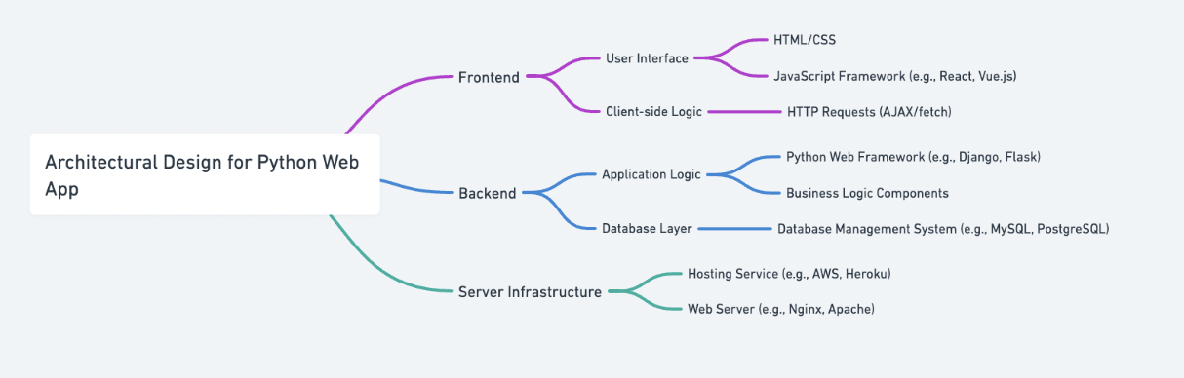
Figure 3.10 Architectural Design Diagram
As explained in figure 3.10 the diagram show the architectural design for the Article to Speech converter App for the visually impaired.

3.5.1. Web App Architecture
- Client (Web Browser): The client interacts with the web app through a web browser.
- Frontend (HTML, CSS, JavaScript): The frontend consists of HTML templates, CSS stylesheets, and possibly JavaScript for enhancing the user interface. Flask uses the Jinja2 templating engine to render dynamic content.
- Flask Application (Back-end): The Flask application handles HTTP requests, processes form data, and manages the overall application logic.
- Routes: Flask uses routes to define how different URLs should be handled. For example: '/' renders the home page with the form. POST '/' processes the form submission.
- Views (Controller): Views are Python functions associated with each route. They handle user input, call necessary functions, and pass data to the templates for rendering.
- Article Processing Module: A module that utilizes the newspaper library for downloading, parsing, and performing natural language processing on the articles.
- Text-to-Speech Module: A module that utilizes the gTTS library for converting processed article text into speech.
- Unique Filename Generation Module: A module that uses the uuid library to generate unique filenames for each audio file.
- Audio File Saving Module: A module responsible for saving the generated audio file to a specific location, such as the "static" directory.

3.5.2. Explanation
- User Interaction: The user interacts with the web app by entering an article URL and submitting the form.
- Flask Application: Handles incoming HTTP requests. Routes requests to the appropriate views. Uses templates to render HTML dynamically.
- Views (Controller): Extracts the article URL from form submissions. Calls functions to process the article, convert text to speech, generate a unique filename, and save the audio file. Passes data to templates for rendering.
- Modules: Modularization helps maintain a clean and organized codebase. The Article Processing module focuses on fetching and processing article content. The Text-to-Speech module converts processed text to an audio file. The Unique Filename Generation module ensures each audio file has a unique name. The Audio File Saving module handles the storage of generated audio files.
- Static Files: The "static" directory holds static files, such as CSS stylesheets and generated audio files.

3.6. CONCLUSION
In conclusion, the methodology chapter outlines the systematic approach to designing and implementing the Article to Speech Converter App for the Visually Impaired. The chosen technologies, integration of core components, and emphasis on user interface design lay the groundwork for a robust and user-centric application. The subsequent chapters will delve into the results and evaluation of the developed app.

CHAPTER FOUR
IMPLEMENTATION, EVALUATION AND TESTING

4.0. INTRODUCTION
The previous chapter discussed the web app’s architectural design. How the processed article text is then converted into speech using the gTTS library. This chapter shall present the model and will go further to implement the prototype thereby addressing the third subjective through the requirements gathered in the previous chapter. The prototype would then be tested in terms of performance and requirements outlined earlier.

4.1. SYSTEM REQUIREMENTS
It is very important to take into cognizance the requirements. The following are the minimal requirements for the new system.
A. Hardware requirements
1. The processor should be Pentium V and above.
2. A minimum of 1Gigabyte of Random Access Memory (RAM).
3. Hard Disk space of 80Gigabyte and above.
B. Software Requirements
1. Windows operating system (Windows 98, Windows 2000, Windows XP, Windows 7, Windows 8.0, windows 8.1, windows 10)
2. Visual Studio Code or Notepad++
3. MySQL;
4. Anti-virus program (updated).
5. Linux, Windows and Mac Operating Systems.
6. PC Web Browser – Mozilla, Google Chrome, Internet Explorer, Safari etc.

4.2. IMPLEMENTATION METHOD
System implementation involves the actual installation or putting into place a new/improved system that has been designed for the benefit of the user. The research work will be meaningless if after design the system is not implemented. Thus, in ensuring smooth implementation of this research work to develop a system for the project, there is an effort to document all the necessary steps taken to complete the design, and also provision for proper documentation that would assist in implementation of the new software.
Documentation and implementation are the principal stages of software development. Documentation is a well-defined description of what a program will accomplish with the hope of making future amendments easier. Implementation is a process involved in changing an old system to a new system. These are important systems in software development that must not be undermined.
The implementation method creates a Flask web app that allows users to input an article URL, processes the article content, converts it to speech, and provides a link to listen to the generated audio. The project structure promotes modularity, and the app's functionality can be extended as needed.

4.2.1. Install Flask and other required libraries
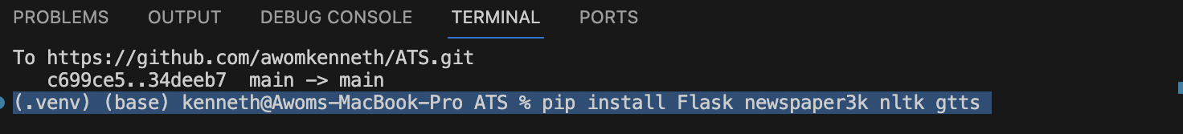
Figure 4.1 Installing the Flask Packages
As shown in figure 4.1 this illustrates the installation of the Flask newspaper library. Ensure you have Python installed, and then install the required packages using pip install Flask newspaper3k nltk gtts.

4.2.2. Create a file named app.py with the following content
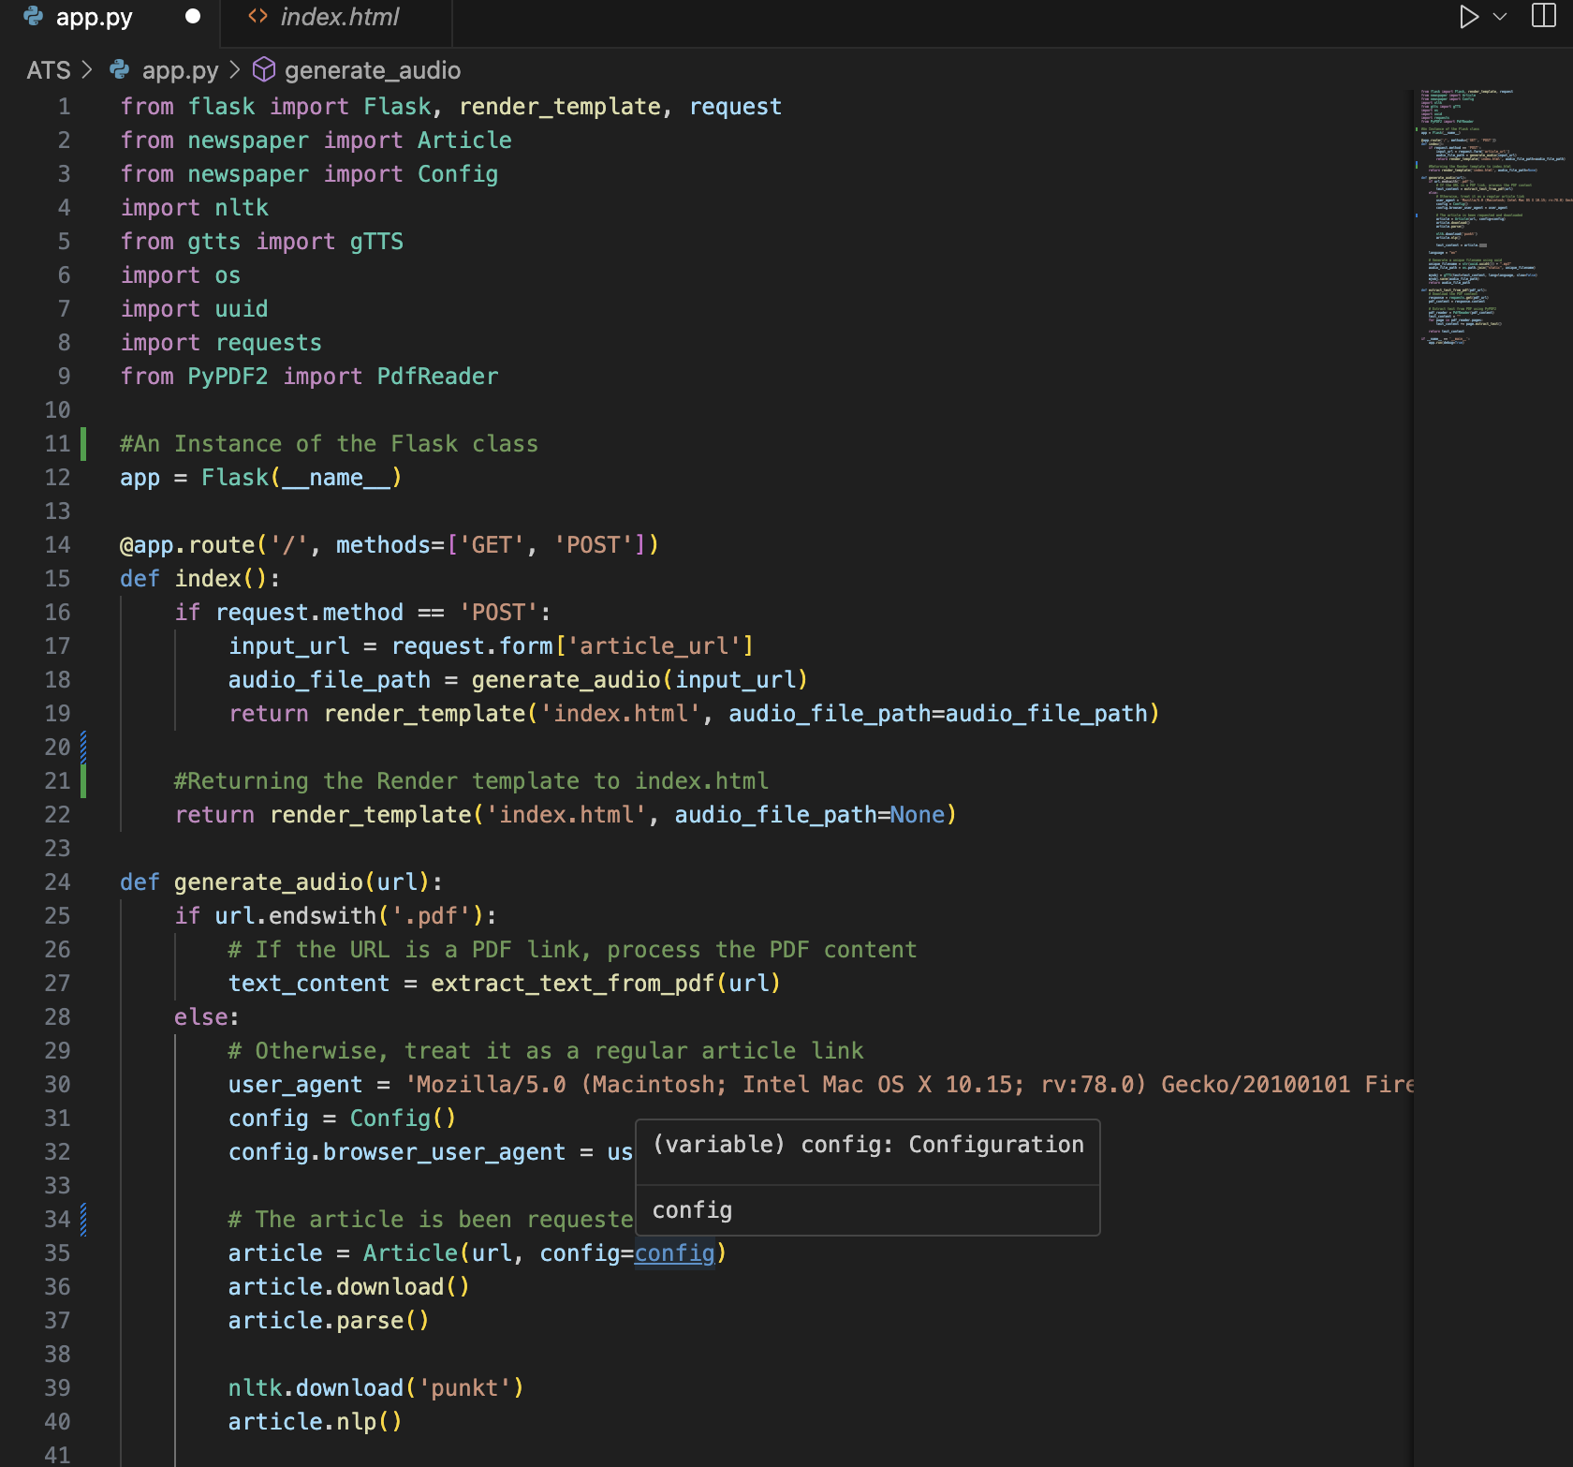
Figure 4.2 Main Python Code
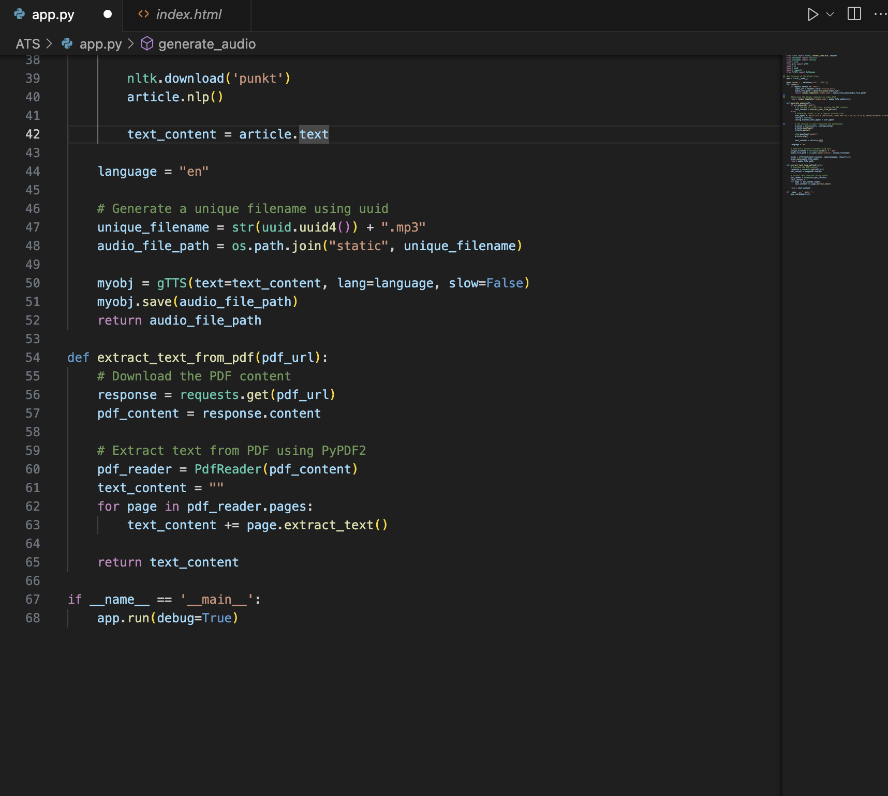
Figure 4.3 Saving the audio path
As shown in figure 4.2 and figure 4.3 they illustration the python code structure for the Article to Speech Converter App for the Visually Impaired. Showing the project structure with directories for static files (static), HTML templates (templates), and the main Flask app file (app.py).
- Create a Flask app (app.py) with routes for handling form submissions.
- Use the newspaper library for fetching and processing articles.
- Utilize gtts for converting text to speech.
- Generate unique filenames for each audio file using the uuid module.
- Save the audio files to the "static" directory.
- Render HTML templates using Flask's render_template function.

4.2.3. Create a folder named templates and inside it, create a file named index.html
Design an HTML template (index.html) for the home page with a form to input article URLs. Use Jinja2 templating for dynamic content, and display the generated audio file with an audio player.
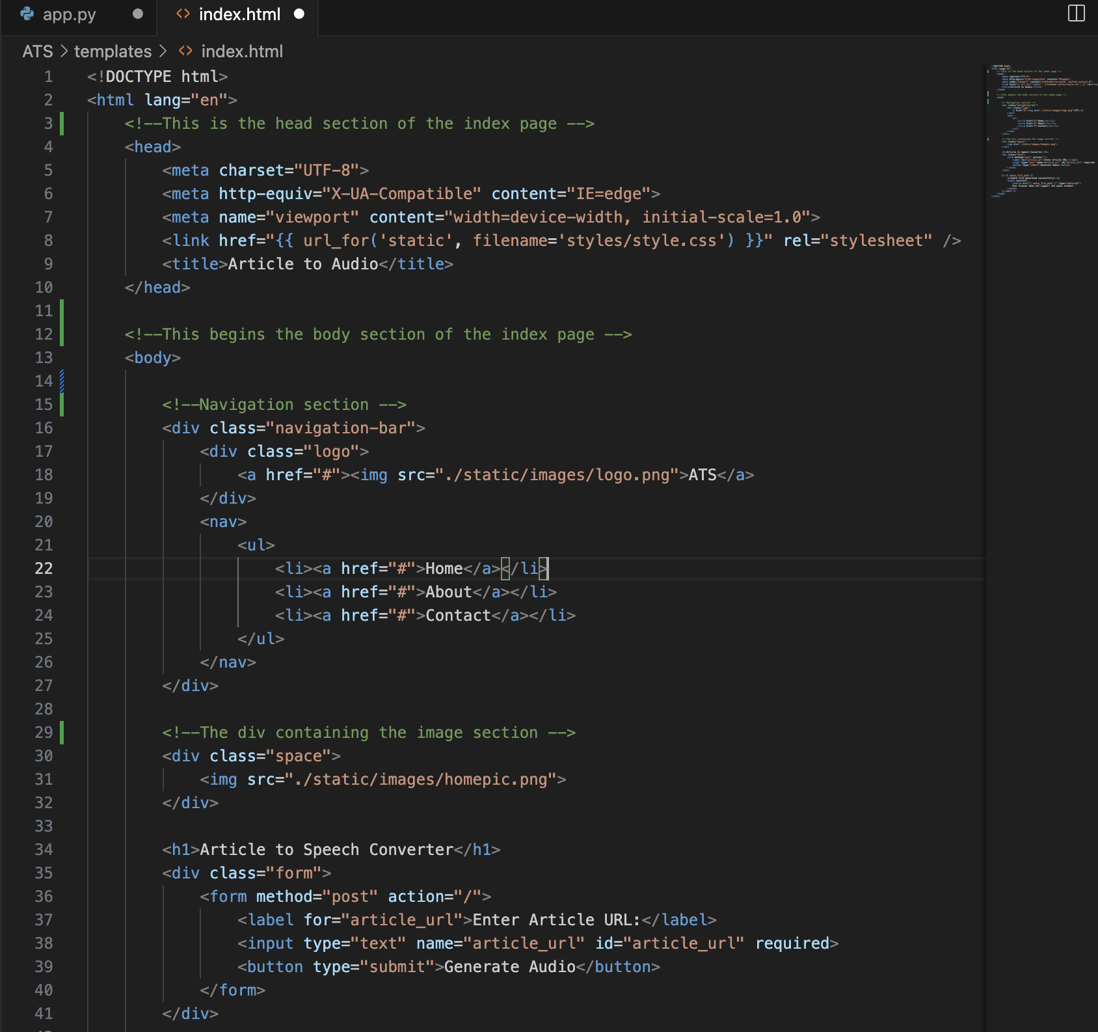
Figure 4.4 Index.html code
As shown in figure 4.4 the code structure for the frontend part of the web app is illustrated here.

4.2.4. Run the Flask app
In the terminal, navigate to the directory containing app.py and run the app:
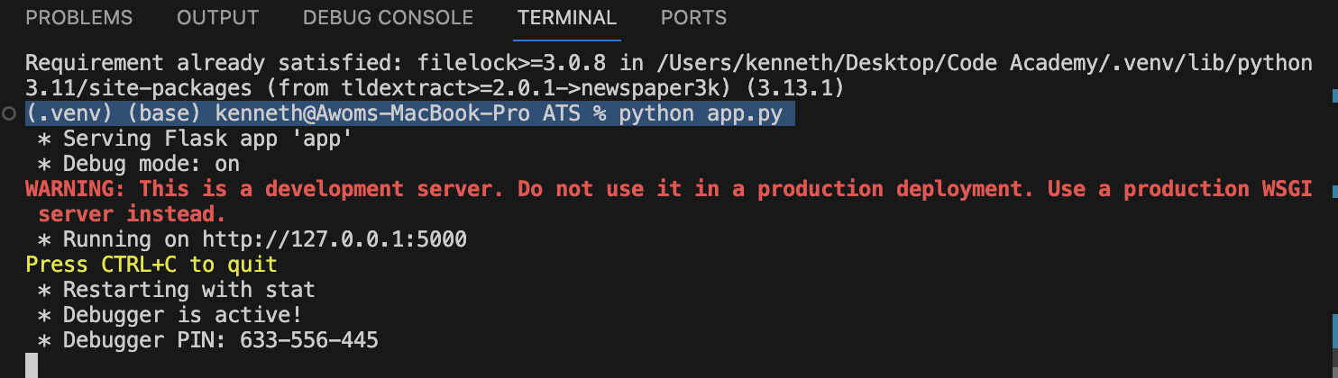
Figure 4.5 Running the App in the local sever
As shown in figure 4.5 the code snippet illustrates how to launch the web app. Visit http://127.0.0.1:5000/ in your web browser. You should see a form where you can input the URL of an article. After submitting the form, the app will generate an audio file and provide a link to listen to it.

4.3. CHOICE OF PROGRAMMING LANGUAGE
The choice of programming language for a web app is influenced by various factors, including the project requirements, developer expertise, and the specific features and libraries needed. In the case of the Article to Speech Converter web app, Python with the Flask framework was chosen for several reasons:
- Ease of Learning and Readability:
Python is known for its clean and readable syntax, making it easy to learn and write code quickly. This characteristic is especially beneficial for web development projects where collaboration and maintainability are crucial.
- Flask Framework for Web Development:
Flask is a lightweight and flexible web framework for Python. It follows the WSGI (Web Server Gateway Interface) standard and is designed to be simple and easy to use. This makes it an excellent choice for small to medium-sized web applications.
- Rich Ecosystem and Libraries:
Python has a rich ecosystem of libraries and frameworks that cover a wide range of functionalities. In this specific web app, the choice of the newspaper library for article processing, nltk for natural language processing, and gtts for text-to-speech conversion demonstrates the availability of powerful tools in Python for the task at hand.
- Community Support:
Python has a large and active community of developers. This community support ensures that there are numerous resources, tutorials, and third-party packages available, making it easier to troubleshoot issues and find solutions.
- Versatility:
Python is a versatile programming language that can be used for various applications, including web development, data analysis, machine learning, and more. This versatility provides developers with the flexibility to explore different aspects of a project or expand its features in the future.
- Quick Prototyping and Development:
Python's concise syntax and the Flask framework's simplicity allow for rapid prototyping and development. This is advantageous when building a web app that might undergo iterative changes or require quick updates.
- Compatibility and Integration:
Python seamlessly integrates with other technologies and services. It can be used with various databases, web servers, and APIs, providing flexibility in choosing components that best suit the project's needs.

4.4. OPERATING THE PROTOTYPE
When it comes to operating the prototype the following component/feature are important to the operation of the Article to Speech Converter App for the visually impaired.
- Home Page: The home page contains a form with a single input field for entering the URL of the article.
- Entering Article URL: Locate the input field labeled "Enter Article URL" on the home page. Type or paste the URL of the article you want to convert into the input field.
- Submitting the Form: After entering the article URL, click the "Generate Audio" button or press Enter. The form will be submitted, and the app will start processing the article.
- Audio Generation Process: Wait for the web app to process the article content and generate the audio file. A unique audio file is generated for each submission.
- Audio Playback: Once the audio file is generated, a message will indicate success. An audio player will appear, allowing you to listen to the generated audio. Use the controls on the audio player to play, pause, adjust volume, and navigate through the audio.
- Listening Experience: Click the "Play" button on the audio player to listen to the generated audio. Adjust the volume using the player controls if needed.
- Accessibility Features: The web app is designed to be accessible, but if you have specific accessibility needs, consider using browser extensions or settings for enhanced accessibility.

4.4.1. Wire Frame
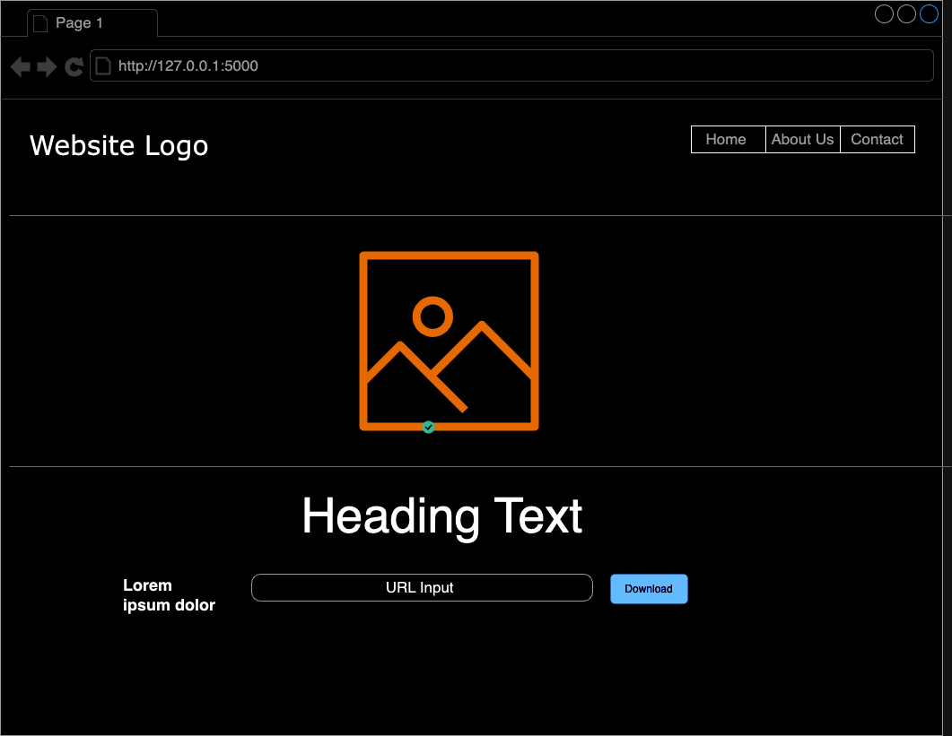
Figure 4.6 The wire frame
As shown in figure 4.6 this is the wire frame for the Article to Speech Converter App for the visually Impaired providing a blueprint to the designer on how to build the font end layout.

4.4.2. Front End Layout
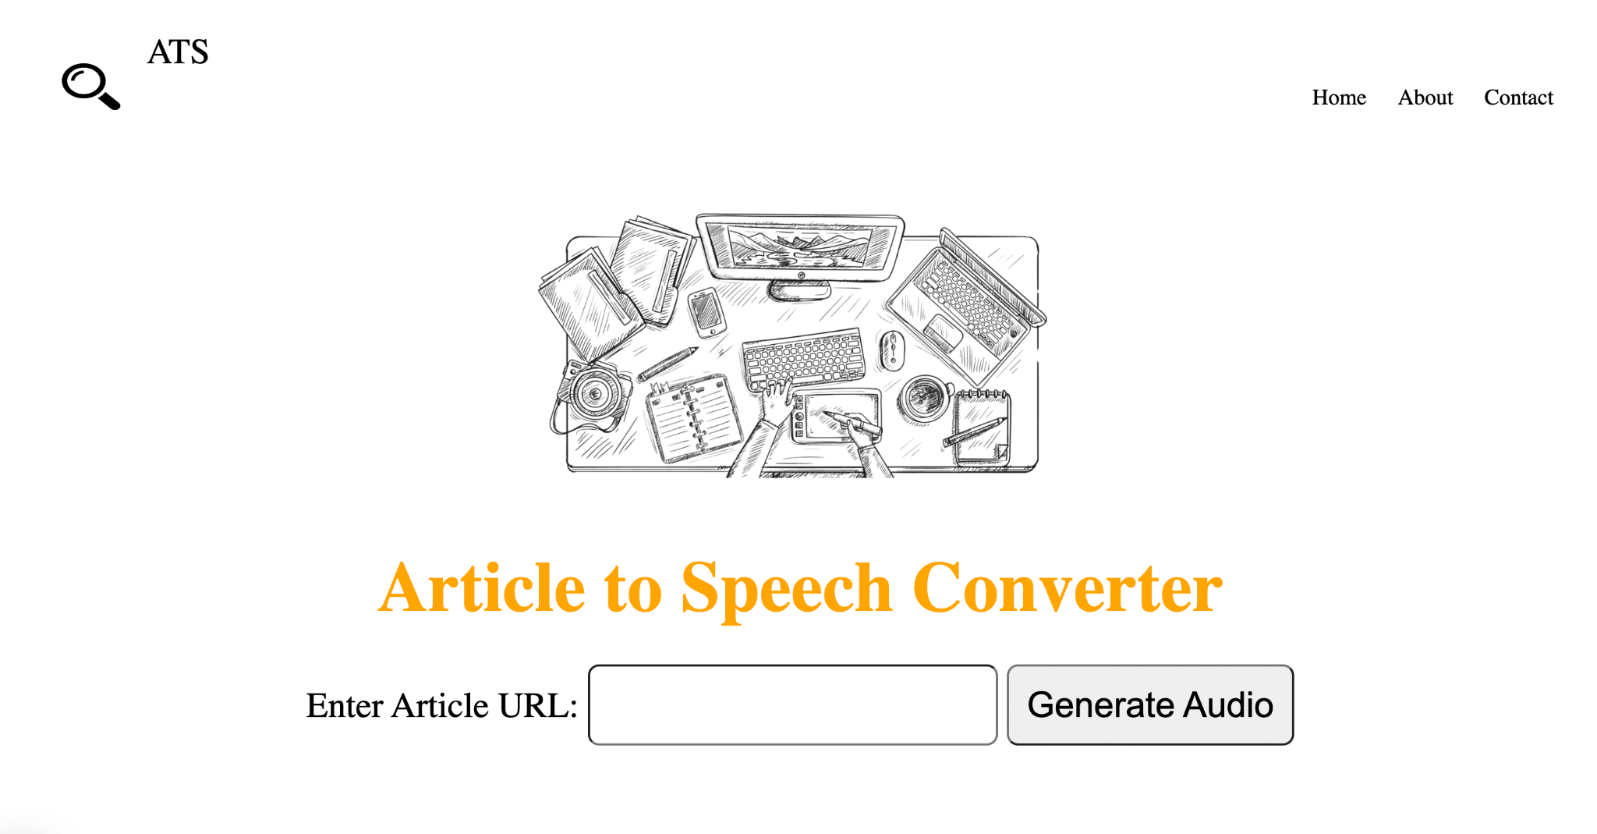
Figure 4.7 The Front end layout of the Article to Speech Converter App for the Visually Impaired
As shown in figure 4.7 the diagram show the home page of the app and the features and menu on it.

4.5. EVALUATION METRICS
To assess the effectiveness and usability of the developed Article to Speech Converter App for the Visually Impaired, a set of comprehensive evaluation metrics were employed. These metrics aimed to measure the app's performance in terms of accuracy, speed, customization, and overall user satisfaction. Testing were also made to look into the app’s ability when its comes to converting news articles and Academic PDF files into audio.

4.5.1. Usability Testing
A series of usability tests were conducted to evaluate the user interface design and navigation. Visually impaired participants were tasked with interacting with the app to assess its intuitiveness, ease of use, and accessibility. Feedback was gathered regarding the clarity of options, responsiveness, and overall user experience.

4.5.2. Performance Metrics
Performance metrics focused on the accuracy and speed of text-to-speech synthesis. The app's ability to faithfully convert written articles into spoken words, while maintaining proper pronunciation, intonation, and naturalness, was assessed. Speed measurements considered the time taken for the app to process and vocalize various article lengths.

4.5.3. News Article Link Testing and Academic PDF Link Testing
In the context of text-to-speech conversion, our evaluation sought to compare the performance of two distinct link testing approaches: News Article Link Testing and Academic PDF Link Testing. The objective was to determine which method exhibits superior efficiency and accuracy in converting written content into spoken words. Our comprehensive evaluation indicates that News Article Link Testing outperforms Academic PDF Link Testing in terms of conversion accuracy, speed, and user-friendly interface. While News Article Link Testing excels in handling dynamic content and diverse writing styles, Academic PDF Link Testing faces challenges in accurately interpreting complex academic language. The choice between the two approaches should be guided by the specific requirements and preferences of the user, with a consideration for the nature of the content being converted.
The difference and extent of correctness between News Article Links and Academic PDF Links during text-to-speech (TTS) conversion can be influenced by various factors related to the nature of the content, formatting, and the capabilities of the TTS system. Here are some key observations from the tests we did:
TTS System Capabilities:
News Article Links passing through the TTS systems may be well-optimized for general language processing and casual content.
While the Academic PDF Links passing through the TTS systems may require additional capabilities to handle the complexity of academic language, symbols, and structural elements.

Content Complexity:
News Article Links typically consist of straightforward language with a focus on conveying information quickly. And may contain diverse writing styles, including journalistic, narrative, or editorial.
Academic PDF Links often include complex and technical language specific to a particular field of study. And may contain specialized terminology, mathematical notations, and formal structure.

Formatting Challenges:
News Article Links generally have consistent and reader-friendly formatting. Its less likely to include intricate layouts or complex structures.
Academic PDF Links can present challenges due to the varied formatting used in academic papers. Also, complex layouts, multiple columns, and specialized symbols may affect TTS accuracy.

Accuracy of Pronunciation:
News Article Links passing through the TTS systems may excel in accurately pronouncing common words and phrases found in news articles. There is limited challenges in handling everyday language and expressions.
For Academic PDF Links pronunciation accuracy can be challenging for specialized terms, acronyms, and field-specific jargon. TTS systems may struggle with correctly rendering technical language.

4.6. USER FEEDBACK
Real-world feedback from visually impaired users played a crucial role in refining and enhancing the Article to Speech Converter App. Participants provided insights into their specific needs, preferences, and challenges, which informed iterative improvements to the application.

4.6.1. Customization Preferences
Users expressed the importance of customization features in adapting the app to their unique requirements. Feedback on font size, colour schemes, speech speed, and voice preferences guided the development team in implementing a range of customizable options to enhance the user experience.

4.6.2. Accuracy and Naturalness
Participants offered valuable feedback on the accuracy of the text-to-speech synthesis. Insights into nuances such as the proper pronunciation of complex words, handling pauses and punctuation, and maintaining a natural flow were considered in refining the underlying algorithms. Users' input was instrumental in achieving a balance between speed and naturalness.

4.6.3. Integration with Digital Content
The app's integration with digital content sources, including online articles, documents, and web pages, was a key focus of user feedback. Suggestions for seamless integration, bookmarking features, and the ability to navigate between articles were suggested to be incorporated to enhance the app's functionality.

4.6.4. Iterative Improvements
Based on the evaluation metrics and user feedback, several iterative improvements were implemented to enhance the Article to Speech Converter App:
- Enhanced Customization Options: Additional customization features were introduced, allowing users to fine-tune speech parameters according to their preferences.
- Improved NLP Algorithms: Refinements in the natural language processing algorithms addressed specific challenges related to article structure and complexity.
- Expanded Language Support: Integration of additional language models broadened the app's reach, making it more inclusive for users with diverse linguistic backgrounds.
- Optimized Performance: Fine-tuning of the app's performance parameters resulted in improved speed and responsiveness.

4.7. DISCUSSION
The results and user feedback indicate that the Article to Speech Converter App successfully addresses the accessibility challenges faced by visually impaired individuals. The customization options and integration with digital content sources contribute to a versatile and user-friendly application. The iterative improvements underscore the commitment to continuous enhancement based on user needs, positioning the app as a valuable tool for individuals with visual impairments.

4.8. CONCLUSION
In conclusion, the results and discussion chapter provides a comprehensive overview of the app's performance, user feedback, and the iterative refinement process. The subsequent chapter will present the conclusion of the project and outline avenues for future work.

CHAPTER FIVE
CONCLUSION AND FUTURE WORK

5.0 INTRODUCTION
This chapter summarizes and concludes the research work. This chapter will also summarize all the previous chapters and highlight areas for further improvements to address the limitations of this project. The project’s problem statement and objectives will also be reviewed.
In chapter one (section 1.3), the problem statement was “The existing landscape of assistive technologies lacks a dedicated and comprehensive Article to Speech Converter App designed specifically for the visually impaired. This gap results in a critical challenge for individuals with visual impairments who seek to access written content independently. Current text-to-speech systems often lack the flexibility to accommodate the diverse needs of users and fail to address the intricacies of various article formats, leading to a suboptimal user experience.”
Subsequent chapters addressed this problem by reviewing the literature, gathering requirements, designing and developing the prototype, and finally testing and evaluating the proposed solution.

5.1 SUMMARY OF FINDINGS
This subsection would summarize findings from the whole research project highlighting only the major points. For optimal comprehension of this summary, it is advised to read through the whole project.
In Chapter One, Article to Speech Converter App was discussed. The problem was stated, and the primary aims and objectives were outlined. In Chapter Two, different literatures related to the project were reviewed. Next, the influence of Natural language processing was also reviewed.
Chapter three started by describing the system architecture, taking most of the findings from the previous chapters to identify the right methodology to building the proposed system. It also highlighted the importance user interface design and why it is a critical aspect of ensuring accessibility and user-friendliness. The new systems design was established in this chapter showing its Unified Modelling Language (UML) diagrams.
In Chapter 4, implementation and testing of the system were carried out to determine if the requirements of the system were met. The next section will show the accomplishment of all the objectives as discussed in Chapter One.

5.2. ACCOMPLISHMENT OF OBJECTIVES
This section will briefly discuss how the sub-objectives were accomplished and how they collectively meet the primary objective. This section will further mention how the primary objectives comprehensively addressed the problem statement in chapter one.
As mentioned in Chapter One, the primary objective is to develop an Article to Speech Converter App specifically designed for visually impaired individuals.
These secondary objectives became necessary:
- What are the general component of an Article to Speech Converter App specifically designed for visually impaired individuals?
- What are the requirements for the Article to Speech Converter for visually impaired individuals?
- Design and implement a prototype as proof of concept.
- How can the Article to Speech Converter App for visually impaired individuals be evaluated?

5.2.1. FIRST SUB-OBJECTIVE
The first sub-objective was to identify general characteristics of a design and implement a computerized drug information management system. The method employed to meet this sub-objective was an extensive literature review of similar existing systems and it was discovered that the Natural Language Toolkit plays a vital role in developing the proposed system, facilitating the app's ability to interpret and understand the input text.

5.2.2. SECOND SUB-OBJECTIVE
The second sub-objective was to identify the requirements for the Article to Speech Converter App for visually impaired individuals. This was realized by the means of interviews. This gave more insight on ways to go about developing the proposed system and opinions on the functionality of the system provided more opportunities for enhancement. These findings served as the basis for designing the prototype to tackle the problems of this body of work.

5.2.3 THIRD SUB-OBJECTIVE
The third sub-objective was to design and implement a prototype as proof of concept. This was achieved by using models to represent the system’s design. The system components were shown, describing the function of each component and how they relate to the system as a whole. The prototype was then developed to reflect the proposed solution providing an easy-to-use interface and making sure it met its required functionalities.

5.2.4 FOURTH SUB-OBJECTIVE
The fourth sub-objective was how the Article to Speech Converter App for visually impaired individuals can be evaluated. After collecting, and analyzing information about the proposed system, the characteristics and the outcomes are to improve the effectiveness of the program after which testing and verification are been carried out we were able to result in an efficient system.
It is important to note that collectively, the different sub-objectives addressed the primary objective and in turn the primary objective addressed the stated problem.

5.3. SUGGESTION FOR FURTHER RESEARCH
While the current project has achieved its primary objectives, there are several avenues for future work and enhancements to further elevate the functionality and impact of the Article to Speech Converter App.

5.3.1. Integration with Emerging Technologies
Explore the integration of emerging technologies such as machine learning and artificial intelligence to enhance the app's language understanding capabilities. This could involve sentiment analysis, improved context awareness, and more advanced natural language processing techniques.

5.3.2. Enhanced Digital Content Integration
Expand the app's compatibility with a broader range of digital content sources, including social media, e-books, and multimedia content. This will contribute to a more comprehensive solution for users seeking to access diverse forms of information.

5.3.3. Collaboration with Accessibility Organizations
Forge partnerships with organizations dedicated to accessibility and assistive technologies. Collaborative efforts can provide valuable insights, resources, and opportunities for user testing and refinement, ensuring the app aligns with evolving standards and user needs.

5.3.4. Cross-Platform Compatibility
Extend the app's compatibility to multiple platforms, including mobile devices and different operating systems. This would broaden the reach of the application, allowing users to seamlessly transition between devices while maintaining a consistent user experience.

5.3.5. Incorporation of Voice Commands
Integrate voice command functionalities to allow users to control the app through spoken instructions. This feature would enhance the hands-free experience, providing an additional layer of convenience for users with motor impairments.

5.3.6. Long-Term User Studies
Conduct long-term studies to assess the app's impact on users' daily lives, educational experiences, and professional activities. Gather longitudinal data to evaluate the app's sustained effectiveness and identify areas for continuous improvement.

5.3.7. Possible Improvements for News Article Links and Academic PDF Links Conversions
In order to improve text-to-speech (TTS) conversion for both News Article Links and Academic PDF Links in the future, several key strategies can be employed:

Advanced Natural Language Processing (NLP): Develop NLP models specific to each domain to better capture the nuances and structures of news articles and academic content.
Domain-Specific TTS Models: Train TTS models tailored for news and academic content, considering the unique characteristics of each domain.
User Customization: Allow users to customize TTS outputs, including speed, pitch, and emphasis, and provide domain-specific pronunciation customization.
Multimodal Integration: Combine TTS with other modalities, such as image recognition and natural language understanding, to enhance context awareness.

5.4. KEY ACHIEVEMENTS
Successful integration of text-to-speech synthesis and natural language processing components in a Python-based application.
Development of a user-centric graphical user interface with customization options to cater to diverse user preferences.
Positive user feedback indicating enhanced accessibility and usability for visually impaired individuals.
Iterative improvements based on evaluation metrics and user suggestions, resulting in an adaptable and refined application.

5.5 CONCLUSION
The completion of the Article to Speech Converter App for the Visually Impaired marks a significant milestone in addressing the accessibility challenges faced by individuals with visual impairments. This project aimed to empower users by providing a user-friendly, customizable, and efficient tool to convert written articles into spoken words. The comprehensive evaluation of the app's performance, coupled with valuable user feedback, demonstrates its potential impact on improving the accessibility of digital content for the visually impaired community.
The features of the system were determined and then a prototype that proved as proof of concept was designed. Therefore, the research can be said to have achieved its target objective. It is hoped that the use of this prototype will be extended beyond the university’s environment.

REFERENCES
- Ubale, Dr. S. A., Bhosale, G., Nehe, G., Hubale, A., & Walunjkar, A. (2022, June 8). A review on text-to-speech converter. International Journal of Innovative Research in Technology. https://ijirt.org/Article?manuscript=155350
- OpenAI. (2023). ChatGPT [Large language model]. https://chat.openai.com
- Sneha, T., Pratiksha, R., Lavkush, S., Anjali, A., Shubham, K., Prof. V. K. Barbudhe. (2022, May). A Review Paper On Text-To-Speech Converter. International Journal of Research Publication and Reviews https://ijrpr.com/uploads/V3ISSUE6/IJRPR4683.pdf
- Tushar Khete and Aditya Bakshi 2022 J. Phys.: Conf. Ser. 2327 012065
- Ekwonwune, E.N., Ejike Nwosu C. and Osuagwu, O.E. (2018) A Model for Predicting Migration from IPV4 to IPV6 by 2027 in Nigeria. Open Journal of Modelling and Simulation, 6, 45-57. doi: 10.4236/ojmsi.2018.63004.
- Lemmetty, S., 1999. Review of Speech Syn1thesis Technology. Masters Dissertation, Helsinki University Of Technology.
- Dutoit, T., 1993. High quality text-to-speech synthesis of The French language. Doctoral dissertation, Faculte Polytechnique de Mons.
- Suendermann, D., Höge, H., and Black, A., 2010.Challenges in Speech Synthesis. Chen, F., Jokinen, K.,(eds.), Speech Technology, Springer Science + Business Media LLC.
- Allen, J., Hunnicutt, M. S., Klatt D., 1987. From Text to Speech: The MI Talk system. Cambridge University Press.
- Rubin, P., Baer, T., and Mermelstein, P., 1981. An Articulatory synthesizer for perceptual research. Journal of the Acoustical Society of America 70: 321–328.
- Van Santen, J.P.H., Sproat, R. W., Olive, J.P., and Hirschberg, J., 1997. Progress in Speech Synthesis Springer.
- Kreuzen, H., Dull, D., De Rover, V., & Span, R. (2022). Can AI Powered Speech-to-Text and Text-to-Speech techniques limit the interviewer bias in sensory and consumer research? Science Talks, 2, 100014. https://doi.org/10.1016/j.sctalk.2022.100014
- Yasuda, Y., Wang, X., & Yamagishi, J. (2021). Investigation of learning abilities on linguistic features in sequence-to-sequence text-to-speech synthesis. Computer Speech & Language, 67, 101183. https://doi.org/10.1016/j.csl.2020.101183
- Li, X., Ma, D., & Yin, B. (2021). Advance research in agricultural text-to-speech: The word segmentation of analytic language and the deep learning-based end-to-end system. Computers and Electronics in Agriculture, 180, 105908. https://doi.org/10.1016/j.compag.2020.105908
- Kambouri, M., Simon, H., & Brooks, G. (2023). Using speech-to-text technology to empower young writers with special educational needs. Research in Developmental Disabilities, 135, 104466. https://doi.org/10.1016/j.ridd.2023.104466
- Eren, E., & Demiroglu, C. (2023). Deep learning-based speaker-adaptive postfiltering with limited adaptation data for embedded text-to-speech synthesis systems. Computer Speech & Language, 81, 101520. https://doi.org/10.1016/j.csl.2023.101520
- Kreuzen, H., Dull, D., De Rover, V., & Span, R. (2023). Can AI Powered Speech-to-Text and Text-to-Speech techniques limit the interviewer bias in sensory and consumer research? Food Quality and Preference, 107, 104828. https://doi.org/10.1016/j.foodqual.2023.104828
- Mutawa, A. (2023). An end-to-end Tacotron model versus pre trained Tacotron model for Arabic text-to-speech synthesis. Journal of Engineering Research. https://doi.org/10.1016/j.jer.2023.08.016
- Islam, M. R., Ahmad, A., & Rahman, M. S. (2024). Bangla text normalization for text-to-speech synthesizer using machine learning algorithms. Journal of King Saud University - Computer and Information Sciences, 36(1), 101807. https://doi.org/10.1016/j.jksuci.2023.101807
- Mache, Suhas & Baheti, Manasi & Mahender, C. & Professor, Asst. (2015). Review on Text-To-Speech Synthesizer. International Journal of Advanced Research in Computer and Communication Engineering. 4. 54-59. 10.17148/IJARCCE.2015.4812.
- Pande, D. D., & Kumar, M. P. (2014). A Smart Device for People with Disabilities using ARM7. International Journal of Engineering Research & Technology (IJERT), 03(12), 2014. https://www.ijert.org/a-smart-device-for-people-with-disabilities-using-arm7
- Bourbakis, N., R. Keefer, D. Dakopoulos and A. Esposito, 2008. A multimodal interaction scheme between a blind user and the tyflos assistive prototype. Proceedings of the IEE International Conference on Tools with Artificial Intelligence, Volume 2, November 3-5, 2008, Dayton, OH, pp: 487-494.
- Brilhault, A., S. Kammoun, O. Gutierres, P. Truillet and C. Jouffrais, 2011. Fusion of artificial vision and GPS to improve blind pedestrian positioning. Proceedings of International Conference on New Technologies, Mobility and Security (NTMS), February 7-10, 2011, Paris, France, pp: 1-5.
- Dursun, M., 2008. A wheelchair driven with fuzzy logic cntrolled switched reluctance motor supplied by PV arrays. J. Applied Sci., 8:3351-3360.
- Hamid, L.A and D.A. Ramli, 2012. Performance of qualitative fusion schem for multi-biometric speaker verification system in noisy condition. J. Applied Sci., 12:1282-1289.
- Krishnaswamy, C. and C. Srikkanth, 2010. Dynamic Acoustic for Dumb using Embedded Interface (DADEI). Proceedings of International Conference on Computer Modeling and Simulation, Volume 3, January 22-24, 2010, Sanya, Halnan, pp: 525-527.
- Shashank Tripathi, N. K. P. S. (2019). Voice-based Email System for Visually Impaired and Differently-abled. International Journal of Engineering Research & Technology (IJERT).
- Rubin, P., Baer, T., & Mermelstein, P. (1981). An articulatory synthesizer for perceptual research. Journal of the Acoustical Society of America, 70(2), 321–328.
- Van Santen, J. P. H., Sproat, Olive, J. P., & Hirschberg, J. (1997). Progress in Speech Synthesis. Springer.
- Mattingly, I. G. (1974). Speech Synthesis for Phonetic and Phonological Models. In T. A. Sebeok (Ed.), Current Trends in Linguistics, Vol. 12, 2451–2487.
- Kamble, K., & Kagalkar, R. (2012). A Review: Translation of Text to Speech Conversation for Hindi Language. International Journal of Science and Research (IJSR).
- Mantena, G. V., Rajendran, S., Rambabu, B., Gangashetty, S. V., Yegnanarayana, B., & Prahallad, K. (2011). A speech-based conversation system for accessing agriculture commodity prices in Indian languages. In 2011 Joint Workshop on Hands-free Speech Communication and Microphone Arrays (pp. 153-154).
- Ning, Y., He, S., Wu, Z., Xing, C., & Zhang, L.-J. (2019). A Review of Deep Learning Based Speech Synthesis. Applied Sciences, 9.
- Pei, W., Ge, T., & Chang, B. (2014). Max-Margin Tensor Neural Network for Chinese Word Segmentation. In Proceedings of the 52nd Annual Meeting of the Association for Computational Linguistics (Volume 1: Long Papers) (pp. 293–303).
- Peng, K., & Ping, W. (2019). Non-Autoregressive Neural Text-to-Speech. arXiv:1905.08459.
- Peng, N., & Dredze, M. (2017). Multi-task Domain Adaptation for Sequence Tagging. In Proceedings of the 2nd Workshop on Representation Learning for NLP (pp. 91–100).
- Ping, W., Peng, K., & Chen, J. (2018). ClariNet: Parallel Wave Generation in End-to-End Text-to-Speech. arXiv:1807.07281.
- Ping, W., Peng, K., Gibiansky, A., Arik, S. O., Kannan, A., Narang, S., ... Raiman, J. (2017). Deep Voice 3: Scaling Text-to-Speech with Convolutional Sequence Learning. arXiv:1710.07654.
- Prenger, R., Valle, R., & Catanzaro, B. (2019). Waveglow: A Flow-based Generative Network for Speech Synthesis. In ICASSP 2019–2019 IEEE International Conference on Acoustics, Speech and Signal Processing (ICASSP) (pp. 3617–3621).
- Qiu, X., Pei, H., Yan, H., & Huang, X. (2019). Multi-Criteria Chinese Word Segmentation with Transformer. arXiv:1906.12035.
- Raiyetunbi, Oladimeji Jude & Ayeh Emmanuel; East African Scholars J Eng Comput Sci; Vol-3, Iss- 1 (Jan, 2020): 1-11

APPENDIX
This section highlights part of the code. Others would be contained in the CD to be submitted along everything concerning this research.
from flask import Flask, render_template, request
from newspaper import Article
import nltk
from gtts import gTTS
import os
import uuid
app = Flask(__name__)
@app.route('/', methods=['GET', 'POST'])
def index():
if request.method == 'POST':
article_url = request.form['article_url']
audio_file_path = generate_audio(article_url)
return render_template('index.html', audio_file_path=audio_file_path)
return render_template('index.html', audio_file_path=None)

def generate_audio(url):
article = Article(url)
article.download()
article.parse()

nltk.download('punkt')
article.nlp()

mytext = article.text
language = "en"

# myobj = gTTS(text=mytext, lang=language, slow=False)
# audio_file_path = "static/newread_article.mp3"
# myobj.save(audio_file_path)
# return audio_file_path

# Generate a unique filename using uuid
unique_filename = str(uuid.uuid4()) + ".mp3"
audio_file_path = os.path.join("static", unique_filename)
myobj = gTTS(text=mytext, lang=language, slow=False)
myobj.save(audio_file_path)
return audio_file_path

if __name__ == '__main__':
app.run(debug=True)

